Chapter 14

Material Requirements Planning (MRP) and ERP

**Background**

This chapter covers a lot of issues. After being hit with a big chunk of inventory theory in Chapter 12, students may be surprised to see inventory appear once again in a different form. As the calculations are all relatively straightforward, the most important goal should be to help students understand the underlying concepts and tradeoffs. The MRP section of the chapter is basically about planning ahead so that everything is in place to produce the final product on time. Instructors should stress that MRP is primarily a planning tool, as opposed to an inventory or short-term dispatching technique. The ERP section describes how firms are trying to significantly extend MRP and create fully integrated business functions where all relevant information is easily obtainable as needed. Students who have worked full-time may have some experience using ERP systems that they could share with the class.

**Class Discussion Ideas**

1. For a specific product and process they understand, have the students identify specific reasons why inventory counts might be inaccurate. Then have them develop possible solutions to these problems.

2. One way to get students thinking about the function of MRP is to begin the lecture by asking them to provide examples of planning “backwards in time” in their own lives. One example might be completing a big term paper by the end of the semester. Do students think about how long each task of writing the paper should take and which tasks need to be completed before others may begin? Do they plan out a schedule of when to start (or at least finish) each task, or do they wait until the last minute? A second example might be cooking a complex meal. Certain ingredients need preparation prior to being mixed into the final dish. If guests arrive at 6:00, do the cooks schedule backwards in time to make sure that the final meal is ready on time?

3. Have students study the advantages and disadvantages of ERP (Slides 87 and 88). Based on these lists and the other information provided in the chapter, do students think that installing an ERP system would be worth it, even at a cost of, say $100 million (for a fairly large firm)? Do the responses differ among students who have worked full-time compared to those who have not? Would their answers differ if they were managing a small- to medium-size firm and the installation cost was, say, $300,000? Are there other ways to attain some of the benefits of ERP without purchasing a system through an expensive ERP provider?

**Active Classroom Learning Exercises**

1. Have the students split into groups and assign each group a different product. It may be necessary to let them examine the product itself or to at least provide pictures or blueprints. Have each group develop a bill of material (BOM) for the product. It might be useful to express the BOM as both a product structure tree and an indented BOM. Have each group share its results with the class.

2. Divide the class into groups and charge each group with the task of designing an effective lot-sizing heuristic that is different from those presented in the text (lot-for-lot, EOQ, and part-period balancing). Have each group describe its heuristic to the class. (It would be interesting to see if any groups come up with something like periodic order quantity, least unit cost, or Silver-Meal.) Go ahead and test the various heuristics against a set of, say, three different patterns of gross requirements. (Excel could help to automate the holding and setup cost calculations on the fly.) Award a prize to the team whose heuristic performs best.

**Company Videos**

1. *MRP at Wheeled Coach (7:45)*

Each ambulance made by Wheeled Coach is comprised of about 3000 different raw materials. The company custom-builds an ambulance designed from an unlimited number of configurations in just 19 days. Particularly for firms producing custom-ordered items like this, MRP is crucial to getting the right parts at the right place at the right time. A detailed BOM is created during sales negations so that Wheeled Coach can properly cost out the item. Once the order is accepted, this BOM feeds into the MRP system. Wheeled Coach freezes its MPS for two weeks, so that changes cannot interfere with the production planning process during that time period. The MRP system incorporates a 3-4 week lead time. Thus, inventory decisions for certain items with much longer lead times, such as aluminum and chassis, are made outside of the MRP system. Wheeled Coach’s old system based dependent demand inventory decisions on historical data, resulting at times in obsolete inventory. In Wheeled Coach’s ever-changing industry with custom orders, MRP has essentially eliminated that problem while reducing overall inventory levels significantly.

Prior to showing the video, instructors might ask students to guess how many different raw materials go into an ambulance and to think about how those items should be managed. Afterwards, instructors might ask how the MPS might look different at Wheeled Coach compared to an automobile assembly line factory such as Ford. Also, do the students think that safety stock would be more important for components at Wheeled Coach or at Ford? Finally, by the company president’s own admission, the MRP system was very expensive. Can the students describe why having too much inventory or having obsolete inventory is such a bad thing? Did the benefits of the MRP purchase seem to outweigh the costs in this case?

**Cinematic Ticklers**

MRP typically time-phases the requirements based on lead times such that everything is ready just-in-time for its intended use. Thus, with little to no slack time in the system, disruptions anywhere along the line can cause the final product to be late. Any clip that shows the main character’s schedule being disrupted and the frantic actions that follow would apply here. One such example is provided below.

1. *Clockwise (John Cleese), Republic Pictures Corporation, 1985*

Headmaster Brian Simpson (Cleese) insists on absolute punctuality from both his staff and students, even if it means keeping tabs on them with binoculars. When he’s elected chairman of the national Headmasters Conference, he’s deeply moved. But when he misses his train to the conference he’s off on one bizarre misadventure after another as he frantically tries, in his very own way, to make up for precious lost time.

**Presentation Slides**

INTRODUCTION (14-1 through 14-9)

Slides 8-9: Because Wheeled Coach deals with so many parts for its custom-made assembled ambulances, an excellent MRP system is crucial for getting the right parts at the right place at the right time.



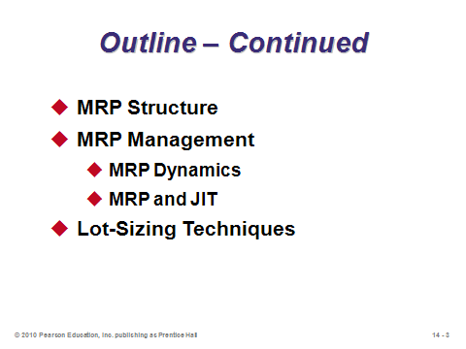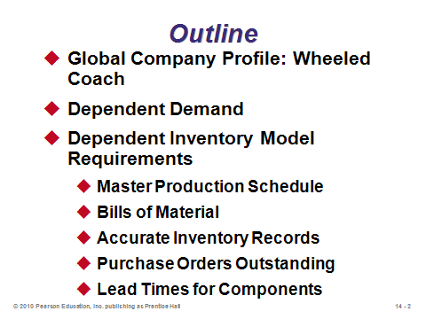

**14-1 14-2 14-3**

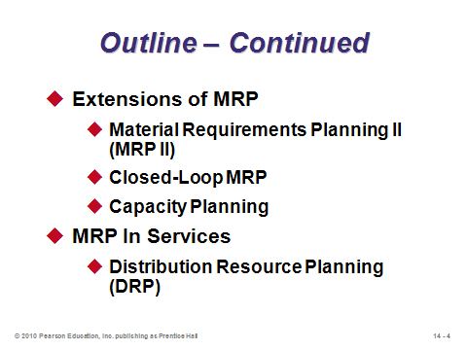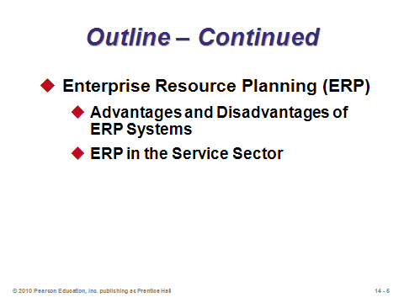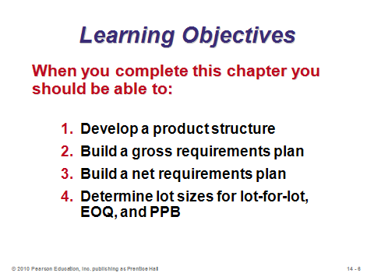

**14-4 14-5 14-6**

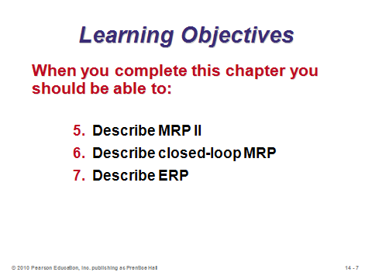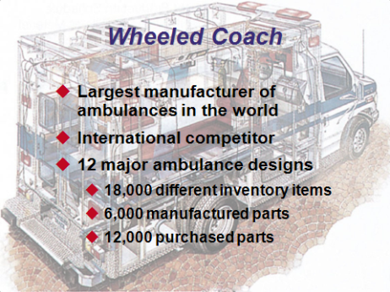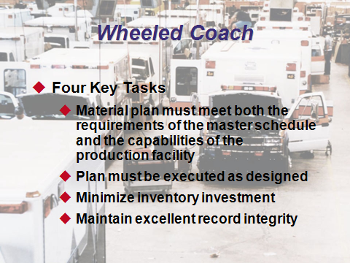

**14-7 14-8 14-9**

DEPENDENT DEMAND (14-10 through 14-12)

Slides 10-12: While Chapter 12 introduced techniques for *independent demand*, Chapter 14 illustrates how to handle *dependent demand*, which occurs when the demand for one item is dependent on the demand for another. In short, for all components that a firm produces to go into a final product, *material requirements planning* (MRP) determines when to begin producing them and in what quantities. Taking lead times into consideration, components are scheduled far enough in advance to ensure that the final product can be completed when scheduled. Slide 11 identifies four benefits of MRP.

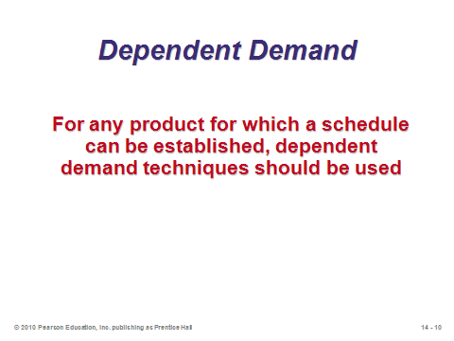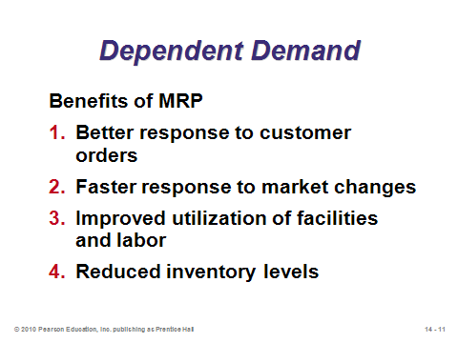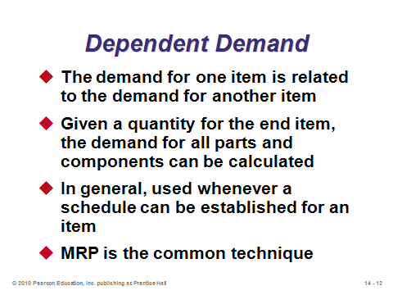

**14-10 14-11 14-12**

DEPENDENT INVENTORY MODEL REQUIREMENTS (14-13 through 14-30)

Slide 13: Operations managers must have knowledge about each of the items identified in this slide in order to implement MRP.

Slides 14-15: The *master production schedule* (MPS) stems from the aggregate plan (Chapter 13). The MPS specifies exactly how many final products will be made and when. This schedule applies to the independent demand items. Based on the MPS, MRP schedules all of the dependent demand items.

Slides 16-17: These slides (Figure 14.1) show where the MPS and MRP fit within the overall planning process. Feedback loops are included in case any of the plans is deemed infeasible.

Slide 18: This slide (Figure 14.2) nicely illustrates how an aggregate production plan based on quantity of product families per month is disaggregated into an MPS showing weekly production of specific products. This slide is arguably the most useful visual tool in the presentation slides to help students understand the relationship between Chapters 13 and 14.

Slides 19-20: These slides emphasize that the MPS applies to end products no matter what process strategy is being used.

Slide 21: This slide (Table 14.1) illustrates two typical MPSs. The time unit is usually either days or weeks, and it is not uncommon to have zero production scheduled for certain days or weeks. (For example, if the quantities are generated from the POQ formula (Chapter 12), then the lot sizes may cover several periods of demand.)

Slides 22-24: A *bill of material* (BOM) breaks a product down into all of its subassemblies and components and identifies how many units of each component go into each parent component/subassembly, all the way up to making one unit of the final product. Note that certain components may appear in more than one place in the BOM, e.g., one-inch fasteners might be used in both an inner casing and an outer casing. (A good test question that catches a lot of students off-guard provides a BOM and asks for the total units of a certain subassembly needed to produce one unit of final product, where the subassembly appears in two places in the BOM.) A BOM is probably best explained visually by going quickly to the one shown in Slide 23 (from Example 1). Slide 24 computes the number of each part needed to make one unit of final product. Students need to be aware that the numbers on the BOM refer to the amount required for the *immediate parent*, not the final product, so the amount needed for the final product has a multiplicative relationship.

Slide 25: When firms practice modular production (see Chapter 5), or *postponement*, they produce major subassemblies or modules to stock but make final products to order. This allows for hundreds or even tens of thousands of different final product configurations based on combinations of perhaps 10-50 modules. When production is organized this way, *modular bills* are used for each module, and no bills of material for final products are needed.

Slides 26-27: These slides describe two other special kinds of bills of material, *planning bills* (or *kits*) and *phantom bills*. Low-level coding is necessary when identical items exist at various levels in the BOM (for example, item D in Slide 23).

Slide 28: The footnote on page 583 of the text dramatically illustrates the importance of accuracy: “Record accuracy of 99% may sound good, but note that even when each component has a availability of 99% and a product has only seven components, the likelihood of a product being completed is only .932 (because .997 = .932).”

Slide 29: If lead times were zero, a tool as sophisticated as MRP would not be necessary. Lead times drive the schedules, as production start times depend upon the lead time of the component in question as well as all of its parents.

Slide 30: This slide (Figure 14.4) presents a *time-phased product structure* of the BOM from Slide 23 (turned on its side). It includes lead times and thus illustrates when each component must start in order for the final product to be completed on time.

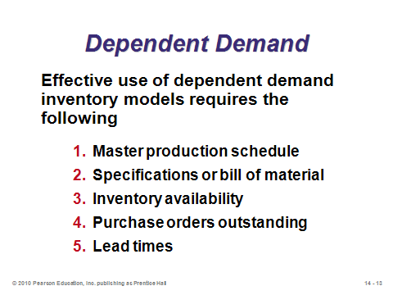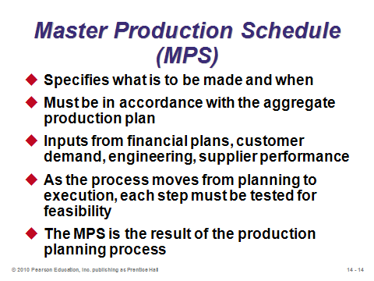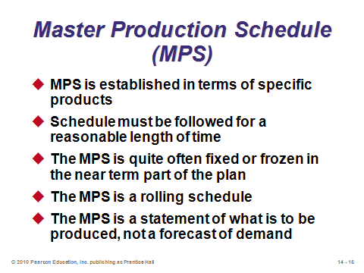

**14-13 14-14 14-15**

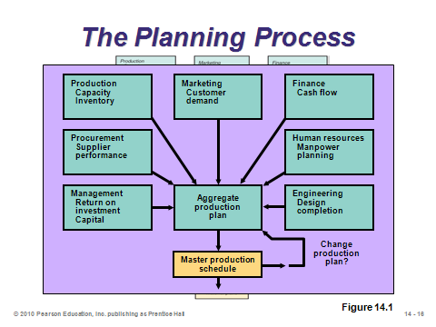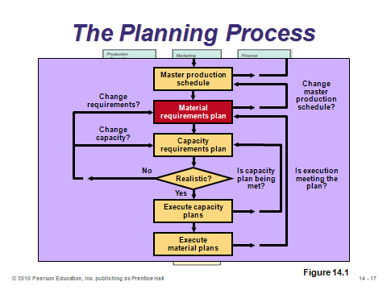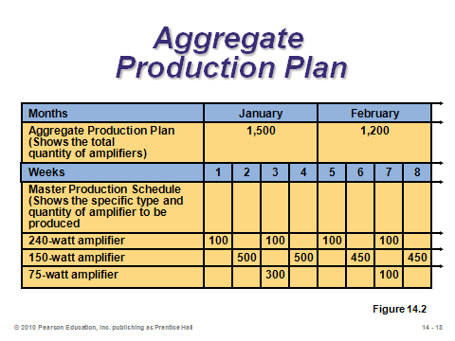

**14-16 14-17 14-18**

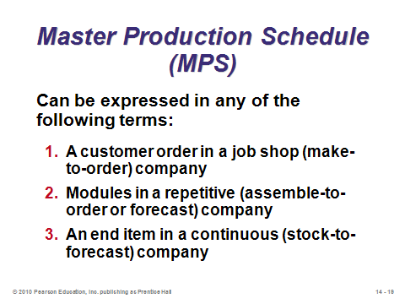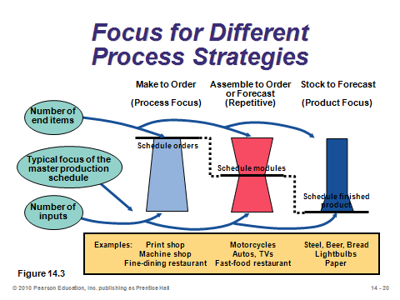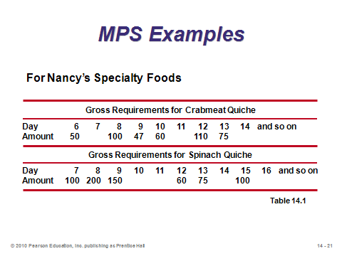

**14-19 14-20 14-21**

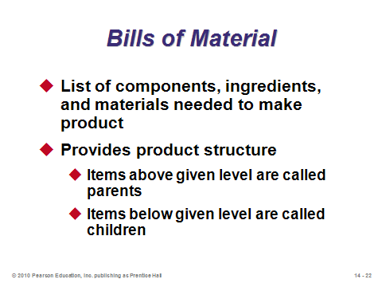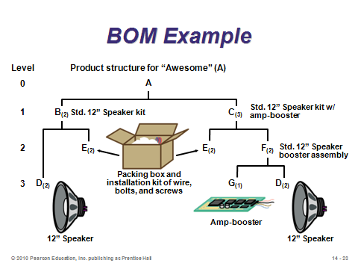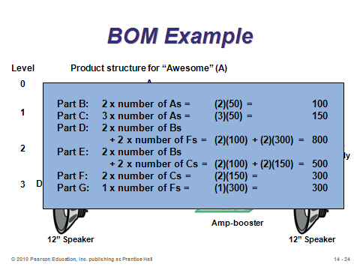

**14-22 14-23 14-24**

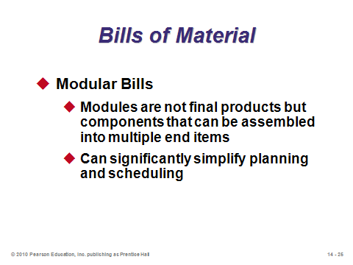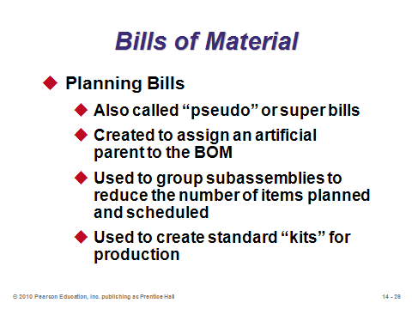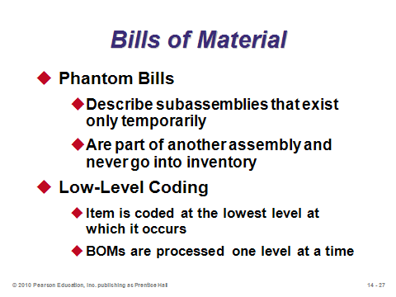

**14-25 14-26 14-27**

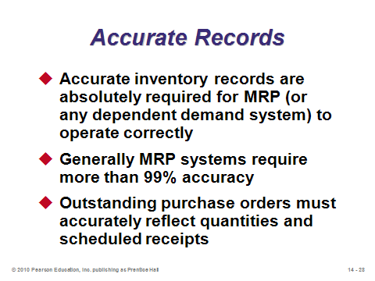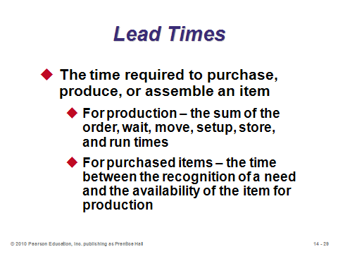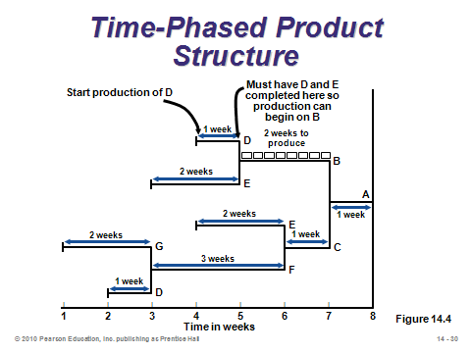

**14-28 14-29 14-30**

MRP STRUCTURE (14-31 through 14-44)

Slide 31: This slide (Figure 14.5) shows the structure of the MRP system. Once set up, the calculations are all mechanical, but tedious. They could be done manually, but excellent computer software eliminates that burden and reduces potential errors.

Slides 32-35: These slides discuss the development of the *gross material requirements plan* (from Example 2, a continuation of Example 1), which is a schedule showing the total demand for an item each time period (which is based on the *order release* of the parent), as well as the order release of the item (i.e., when production must begin or the item must be ordered). Note that demand for an item with multiple parents is combined into a single gross material requirements plan for that item.

Slides 36-40: These slides (Example 3, a continuation of Example 2) discuss the *net material requirements plan*, which adjusts the gross material requirements plan to account for on-hand inventory (and allocations and scheduled receipts—see Slide 41). Slides 36-37 provide the actual plan for each item, while Slides 38-40 describe the calculations for items A and B. The superscripts indicate the source (parent) of the demand. The *planned order release* indicates when to start producing or ordering the part, time-phased from the *planned order receipt* to account for the lead time.

Slide 41: MRP gross requirements can combine multiple products, spare parts, and items sold directly into a single gross material requirements plan. This slide (Figure 14.6) provides an example.

Slide 42: Most inventory systems also note the number of units in inventory that have been assigned to specific future production but not yet used or issued from the stockroom. Such items are often referred to as *allocated* items. Allocated items increase requirements and may then be included in an MRP planning sheet. This slide presents the formula for net requirements.

Slide 43: This slide (Figure 14.7) provides an example of how gross requirements would be adjusted by allocations.

Slide 44: As with independent demand (Chapter 12), safety stock may be necessary in dependent demand systems to account for uncertainty.

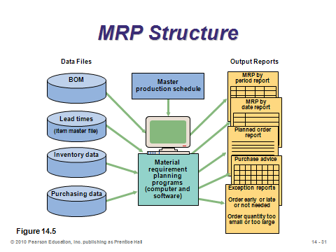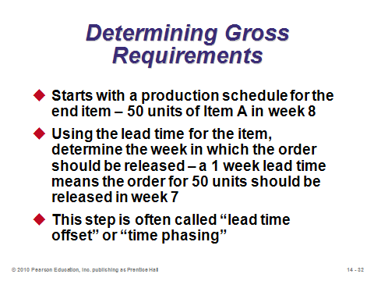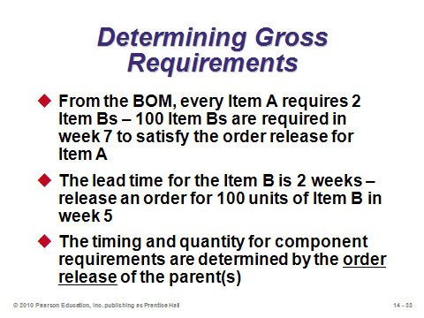

**14-31 14-32 14-33**

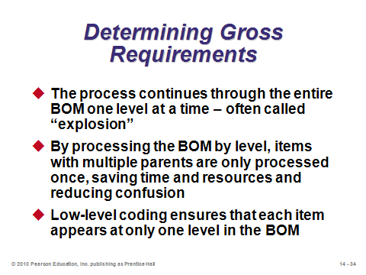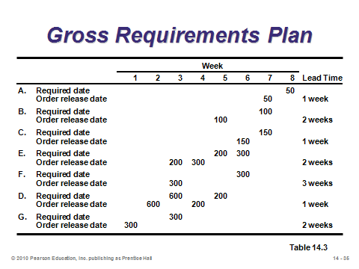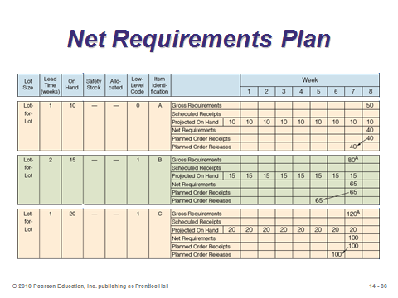

**14-34 14-35 14-36**

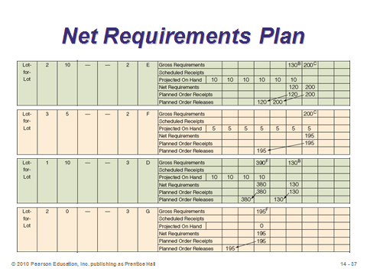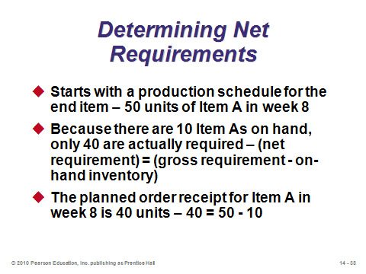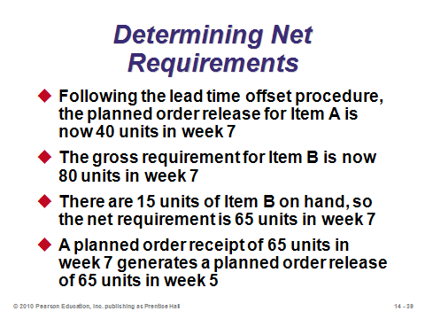

**14-37 14-38 14-39**

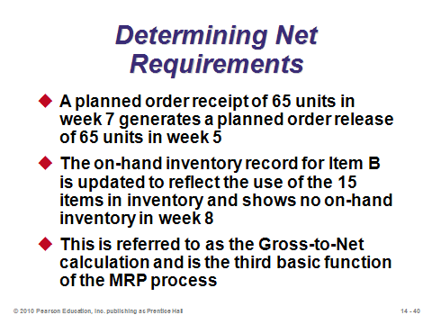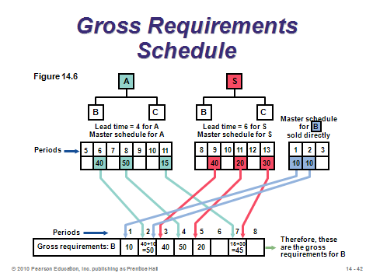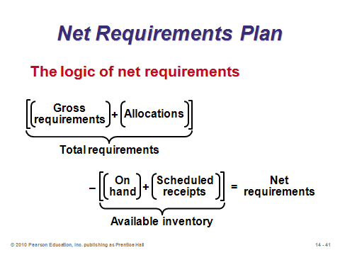

**14-40 14-41 14-42**

**14-43 14-44**

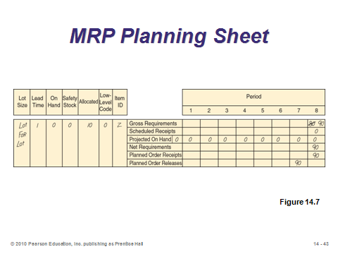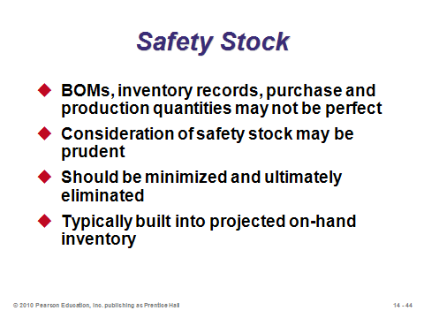

MRP MANAGEMENT (14-45 through 14-50)

Slide 45: MRP schedules production for a specified length of time, such as two weeks, eight weeks, etc. However, during that time, new orders arrive or other conditions change that might alter the net requirements for items. And any such change has a cascading effect down the whole product tree. To avoid making too many alterations to previously scheduled planned order releases, companies can implement techniques to reduce the *nervousness* of the system. One technique is the use of *time fences*, which allow a segment of the master schedule to be designated as “not to be rescheduled,” i.e., it is considered to be *frozen*. A second technique is *pegging,* which involves tracing upward in the BOM from the component to the parent item. By pegging upward, the production planner can determine the cause for the requirement and make a judgment about the necessity for a change in the schedule. Instructors may want to share that several researchers have studied issues surrounding MRP nervousness, and some have proposed more sophisticated lot-sizing models that incorporate a production change cost (that could equal infinity for frozen parts of the schedule).

Slides 46-50: MRP provides a daily or weekly plan, but it does not provide more detailed scheduling than that. When MRP and JIT are combined, MRP can provide the plan and an accurate picture of requirements; then JIT can rapidly move material in small batches, reducing WIP inventory. These slides cover four approaches for integrating MRP and JIT. Slide 47 describes *finite capacity scheduling* (Chapter 15), which considers department and machine capacity—as opposed to basic MRP, which assumes no capacity limits. Slide 48 provides the six steps for the *small bucket approach*. Slide 49 described the *balanced flow* *approach*, which incorporates traditional JIT techniques such as kanbans, visual signals, and reliable suppliers (Chapter 16). Slide 50 describes the use of a *supermarket*. Essentially, the firm maintains a large enough pool of common components that can be withdrawn as needed, eliminating the need for MRP for those items.

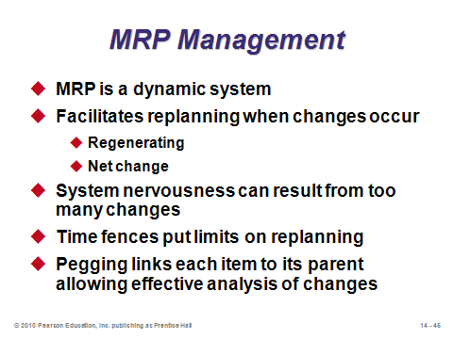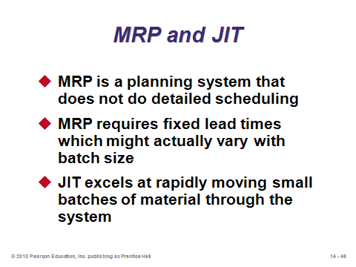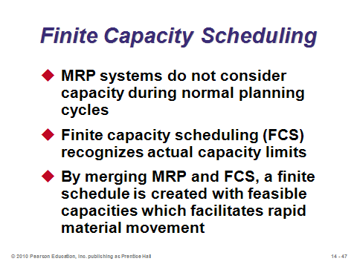

**14-45 14-46 14-47**

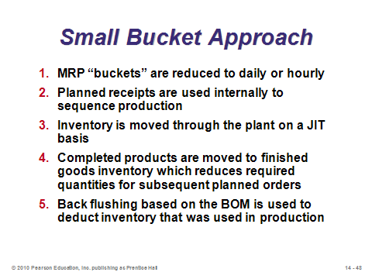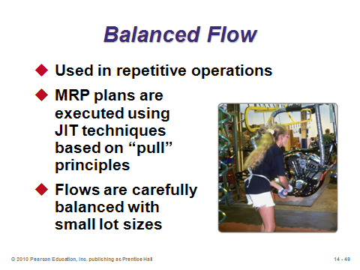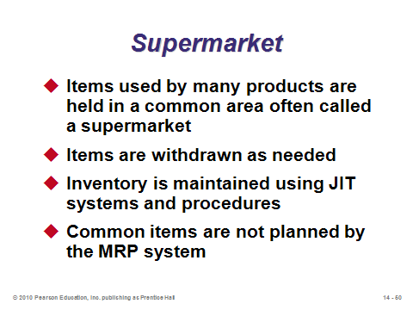

**14-48 14-49 14-50**

LOT-SIZING TECHNIQUES (14-51 through 14-62)

Slides 51-52: The most important managerial decision in standard MRP is the lot-sizing decisions. Firms may utilize a *lot-for-lot* approach, which means producing or ordering exactly the planned order release for that period. However, a setup cost may be incurred every time, which is why other lot-sizing rules consider producing in larger batches that take advantage of economies of scale. Like the EOQ model, these techniques look for a balance between holding and setup costs. The main alternate method discussed in the text is *part period balancing*, which selects the order quantity each time that best matches holding and setup costs (based on the idea that for the infinite time horizon EOQ model, annual holding cost exactly equals annual setup cost). The Wagner-Whitin algorithm is the optimal solution to the finite-horizon scheduling problem, but it is generally too onerous to compute by hand. (Note that other lot-sizing heuristics have been proposed that are beyond the scope of this text, including *Silver-Meal* and *least unit cost*. A nice modification of the EOQ lot size is known as a *periodic order quantity*, which determines the average number of periods of demand that the EOQ would cover and has the user always order enough to cover that many periods. The EOQ itself generally performs poorly because in some periods it may leave enough inventory in place to cover only a partial period of demand—this is a waste because a setup would still have to be incurred that period anyway. Finally, instructors might note that for purchased parts, researchers have modified and tested these lot-sizing heuristics for the case of both all-units and incremental quantity discounts.)

Slides 53-60: These slides cover Examples 4-6, which apply three different lot-sizing rules to the same gross requirements pattern. Slides 53-54 (Example 4) apply the lot-for-lot rule. Inventory is never held when using lot-for-lot, but setup costs are maximized. Slides 55-56 (Example 5) apply the EOQ (infinite horizon) lot size. Notice how this technique performs even worse than lot-for-lot due in several cases to holding inventory that does not meet the full week’s demand. Slides 57-59 (Example 6) show how to apply part period balancing. Note how both the lot size and the number of periods of demand covered by the order can change each time. Slide 60 compares the costs of the three techniques. In this example, part period balancing was the best heuristic tested, while the optimal Wagner-Whitin algorithm would have improved costs by an additional 7.1%.

Slides 61-62: These slides provide some summary information about lot sizing. No matter which method is used, the changes caused by the rolling horizon, new orders, and other factors cause nervousness in the system, which needs to be managed. As a long-term goal, firms should try to reduce setup costs to the point where lot-for-lot (hence just-in-time production) becomes economically viable.

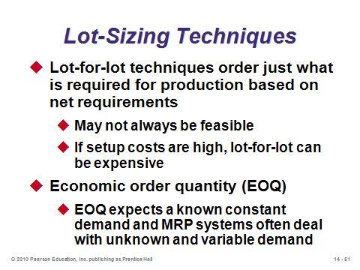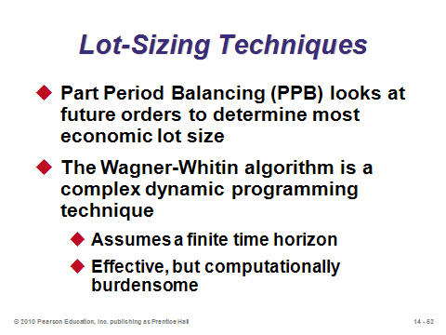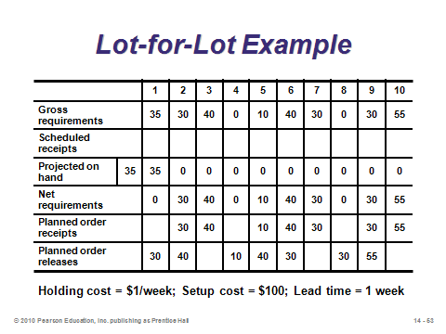

**14-51 14-52 14-53**

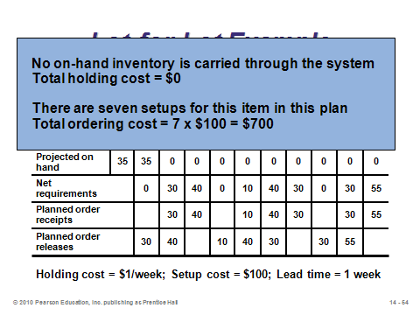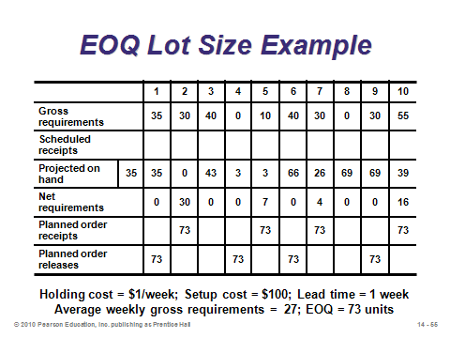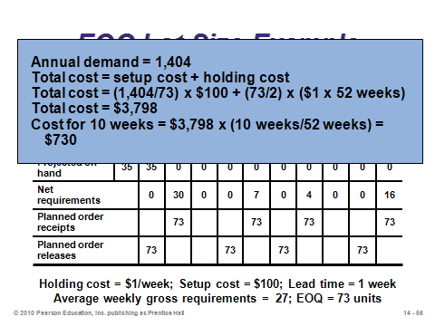

**14-54 14-55 14-56**

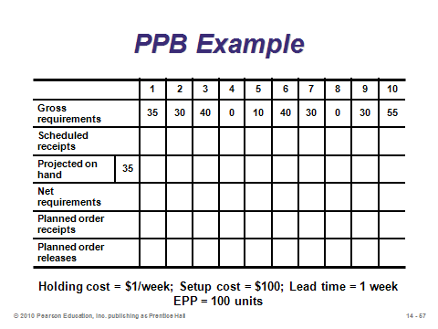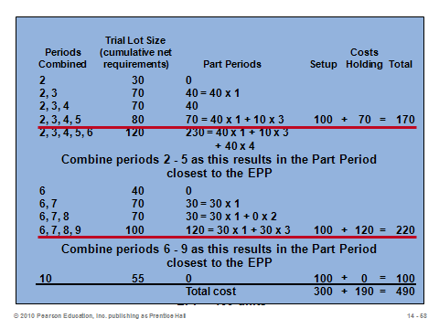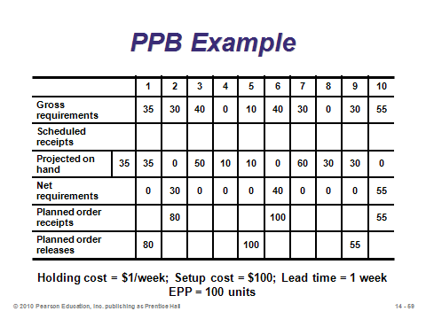

**14-57 14-58 14-59**

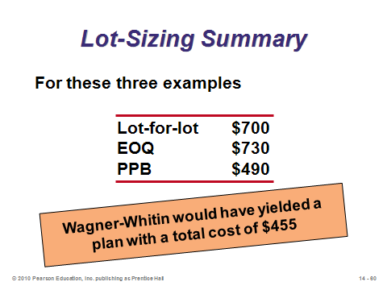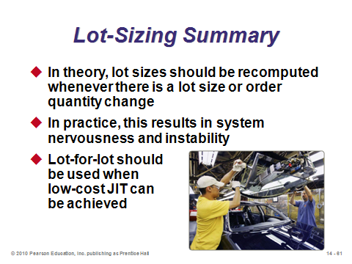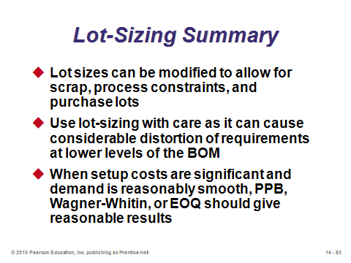

**14-60 14-61 14-62**

EXTENSIONS OF MRP (14-63 through 14-71)

Slides 64-65: These slides describe *material resource planning*, known as MRP II. Similar to basic MRP, the system can determine needs not only for units, but also for scheduling resources such as labor hours, machine hours, scrap, and payables (cost). Slide 65 (Table 14.4) provides an example.

Slide 66: Virtually all commercial MRP software applications provide *closed-loop MRP systems*, which provide feedback to the capacity plan, master production schedule, and production plan. This slide (Figure 14.8) provides a schematic of the interactions.

Slides 67-71: These slides show how closed-loop MRP can assist in capacity planning. The system produces *load reports*, which show the resource requirements in a work center for all work currently assigned there as well as all planned and expected orders. When capacity is exceeded, smoothing tactics (Slide 68) can be implemented to try to bring the load back within capacity. The idea beyond *overlapping* is that rather than having finished parts wait around for the entire lot to be completed, they are sent ahead so that the setup on the next operation can begin. Then when the rest of the lot arrives, the setup has already been completed so there is no additional waiting time for those units. *Lot splitting* is a similar idea, but two full setups still might take place because the order has actually been broken up (and it’s possible that another order may come in between). *Operations splitting* also breaks up an order, but it sends the smaller lots to two simultaneous operations as opposed to sending them at different times. Slides 69-71 (Example 7) illustrate how order splitting can be used to smooth the resource load.

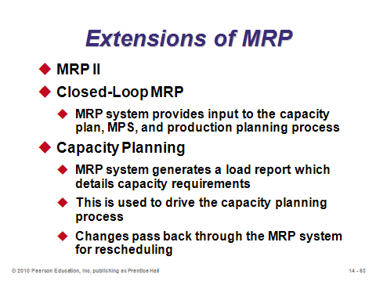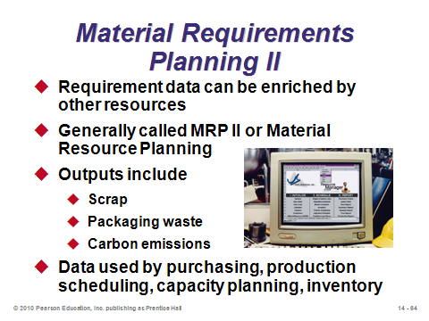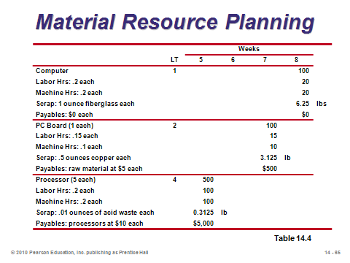

**14-63 14-64 14-65**

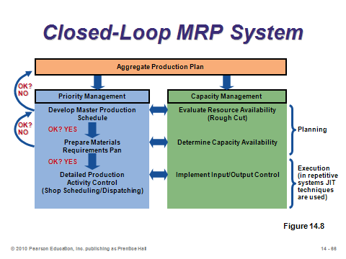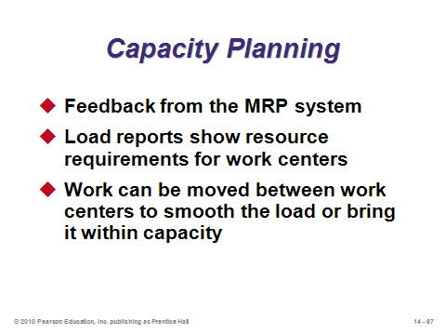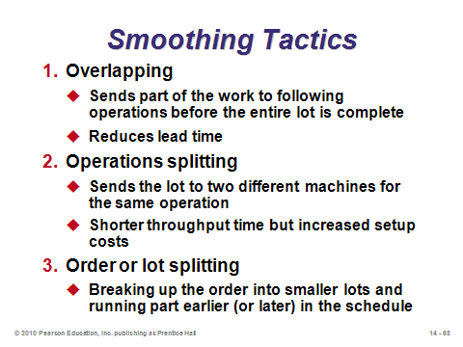

**14-66 14-67 14-68**

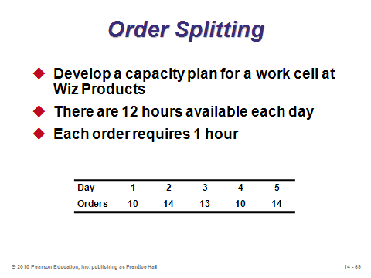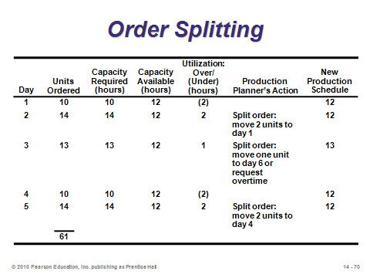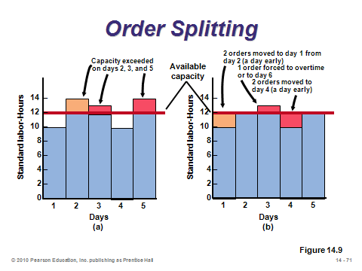

**14-69 14-70 14-71**

MRP IN SERVICES (14-72 through 14-76)

Slide 72: Services or service items may have dependent demand (and hence require MRP) as well. For example, restaurants have ingredients and side dishes dependent upon the demand for meals; hospitals utilize equipment, materials, and supplies based on the demand for surgeries; and hotels require materials, furniture, and decorations in response to demand for renovations.

Slides 73-75: These slides all come from Figure 14.10, which shows an example product structure tree, bill of materials, and bill of labor for a top-selling entrée in a New Orleans restaurant.

Slide 76: *Distribution resource planning* (DRP) extends MRP beyond one firm into multiple firms within the supply chain. DRP is a time-phased stock-replenishment plan for all levels of a distribution network. This represents an excellent mechanism for enhancing supply chain coordination (Chapter 11).

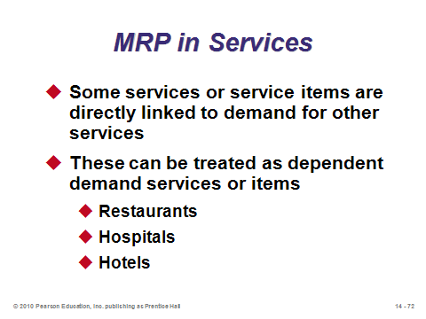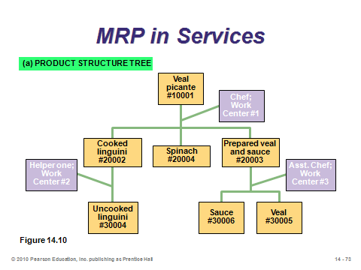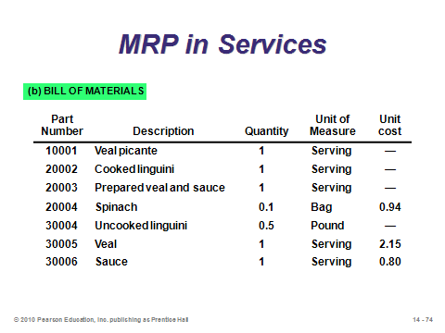

**14-72 14-73 14-74**

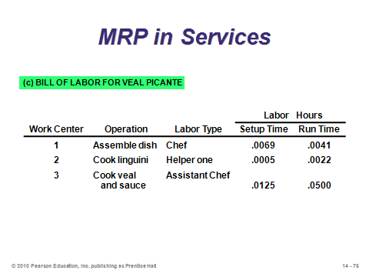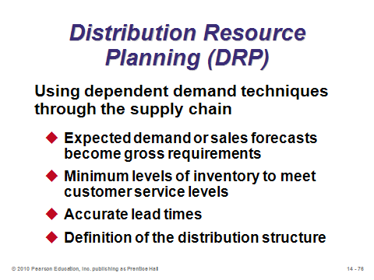

**14-75 14-76**

ENTERPRISE RESOURCE PLANNING (ERP) (14-77 through 14-89)

Slides 77-78: *Enterprise resource planning* (ERP) is software that allows companies to (1) automate and integrate many of their business processes, (2) share a common database and business practices throughout the enterprise, and (3) produce information in real time. The basic idea is certainly a noble one—to try to tie all information systems together so that employees can have access to relevant data from any department. In an ERP system, data are entered only once in a common, complete, and consistent database shared by all applications. These are almost always custom-designed systems provided by companies specializing in ERP. The cost of setting up such systems is usually counted in the millions of dollars and sometimes in the hundreds of millions. *Most* ERP implementations exceed budget projections and take longer than anticipated. Many success stories exist about ERP, as well as many horror stories. In general, ERP does not *solve* problems—it only provides the information. Other solution software or services need to be purchased for that kind of assistance.

Slides 79-83: These slides emphasize different sections of Figure 14.11, which is a schematic showing some of the ERP relationships for a manufacturing firm. Notice that ERP often extends into the supply chain to include customers (*customer relationship management* (CRM) software) and suppliers (*supply chain management* (SCM) software).

Slide 86: This slide (Figure 14.12) shows a set of SAP AG’s many available modules for ERP. We can see why ERP is truly “enterprise-wide.”

Slides 87-88: The advantages and disadvantages of ERP systems are identified in Slides 87 and 88, respectively. ERP is a high-profile implementation with substantial potential gains but many potential pitfalls. Employees tend to either love it or hate it.

Slide 89: Service industries have implemented ERP as well.

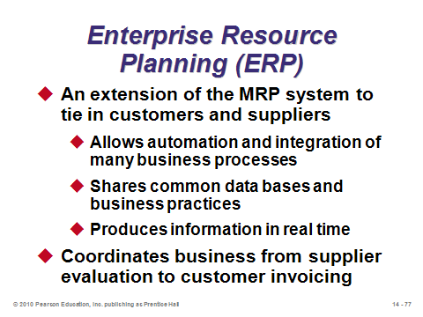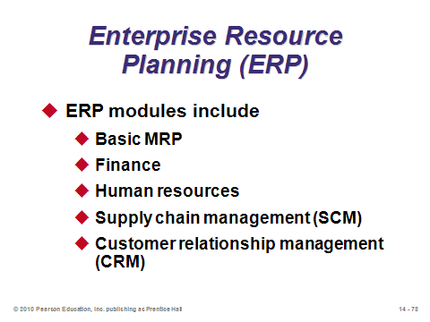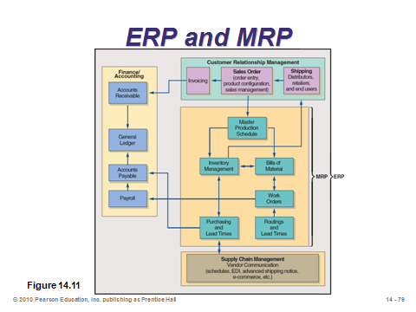

**14-77 14-78 14-79**

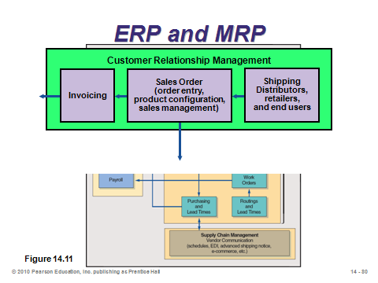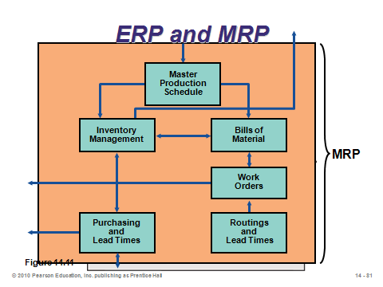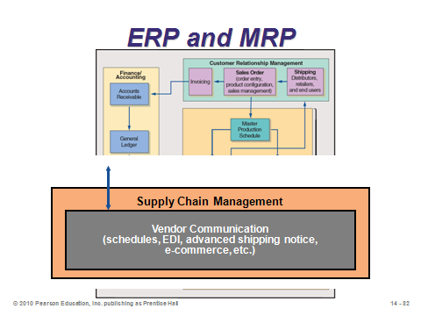

**14-80 14-81 14-82**

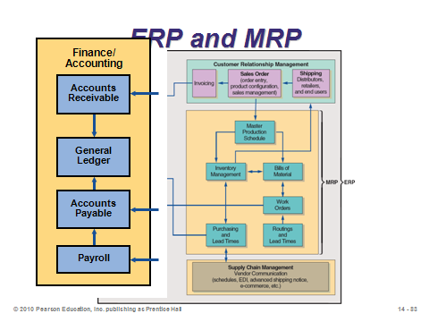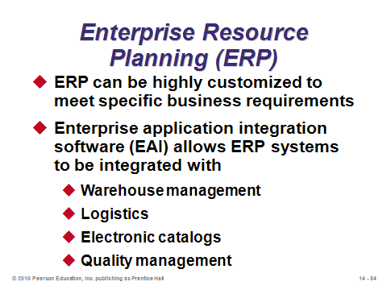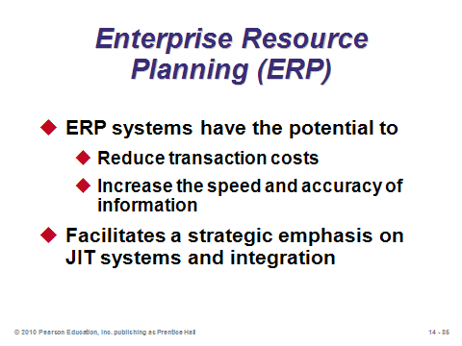

**14-83 14-84 14-85**

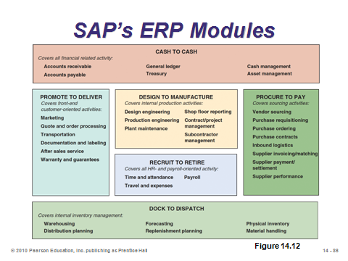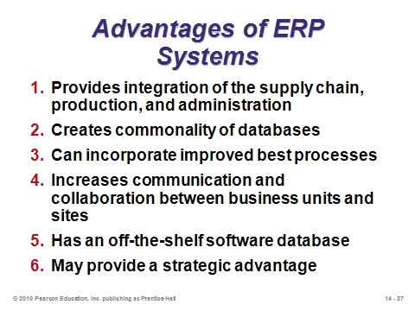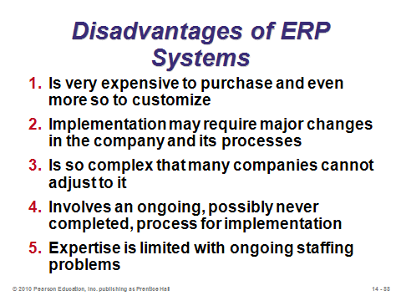

**14-86 14-87 14-88**

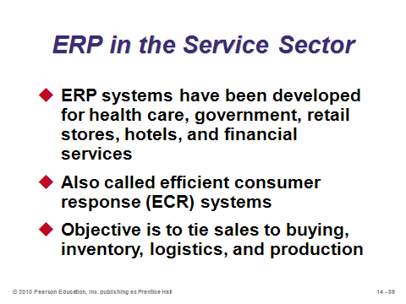

**14-89**

**Additional Assignment Ideas**

1. Have the students identify university bookstore items that could be classified as dependent demand items. This will be a bit of a challenge as most retail items are independent demand items. There will be some items, like student CDs, linked to specific textbooks that could be classified as dependent demand.

2. There are many ERP (Enterprise Resource Planning) software packages. Visit the Web sites representing any two of these companies and describe the distinguishing features of their product. What are the various modules? How can the software be tailored to specific industries? (Hint: The big ones are: SAP and Oracle/PeopleSoft/JD Edwards.)

**Additional Case Studies**

Internet Case Study (www.pearsonglobaleditions.com/heizer)

* *Auto Parts, Inc*.: Distributor of automobile replacement parts has major MRP problems.

Harvard Case Studies (http://harvardbusinessonline.hbsp.harvard.edu)

* *Digital Equipment Corp*.: *The Endpoint Model* (#688-059): Describes implementation of an MRP II system to reduce cycle time of orders.
* *Tektronix, Inc*. *Global ERP Implementation* (#699-043): Tektronix's implementation of an ERP system in its three global business divisions.
* *Vardelay Industries, Inc*. (#697-037): Discusses ERP and related issues of process reengineering, standardization, and change management.
* *Moore Medical Corp*. (#601-142): Examines Moore’s ERP investment and further investment in additional modules.

Richard Ivey School of Business (http://cases.ivey.uwo.ca/cases/pages/home.aspx)

* *Enterprise Resource Planning Software-Ongoing Maintenance Cost Benefit Analysis* (#9B06E012): This case study discusses options that PeopleSoft customers and, by extension, other enterprise software owners pursue to minimize enterprise resource planning (ERP) ongoing costs of ownership.

**Internet Resources**

|  |  |
| --- | --- |
| American Software | www.amsoftware.com |
| APICS magazine online edition | www.apics.org/resources/magazine |
| Armstrong Management Group | www.armstrongmg.com |
| Business Research in Information and Technology | www.brint.com |
| CMS Software, Inc. | www.cmssoftware.com |
| i2 Technologies | www.i2.com |
| Intelligent Enterprise Software | www.iqms.com |
| Oracle/Peoplesoft | www.oracle.com |
| SAP America | www.sap.com |
| Software evaluation | www.technologyevaluation.com |
| SSA Global | www.ssaglobal.com |

**Other Supplementary Material**

Learning Game

Fish, L. (2006). Materials Requirements Planning: Tinkertoy Lawn Mower Activity. *Decision Sciences Journal of Innovative Education*, 4(1), 129-140.

* + Teaching brief describes a hands-on exercise to develop fundamental skills in MRP.